Terraform

How to install terraform?

4. Use this command and install Terraform.

A) ls

B) tmp

C) mkdir terraform_folder

D) cd terraform_folder

Search **Download Terraform** on your Browser. Copy the Link the same as the below image and used it with **wget** as the next step command in the place of that link. 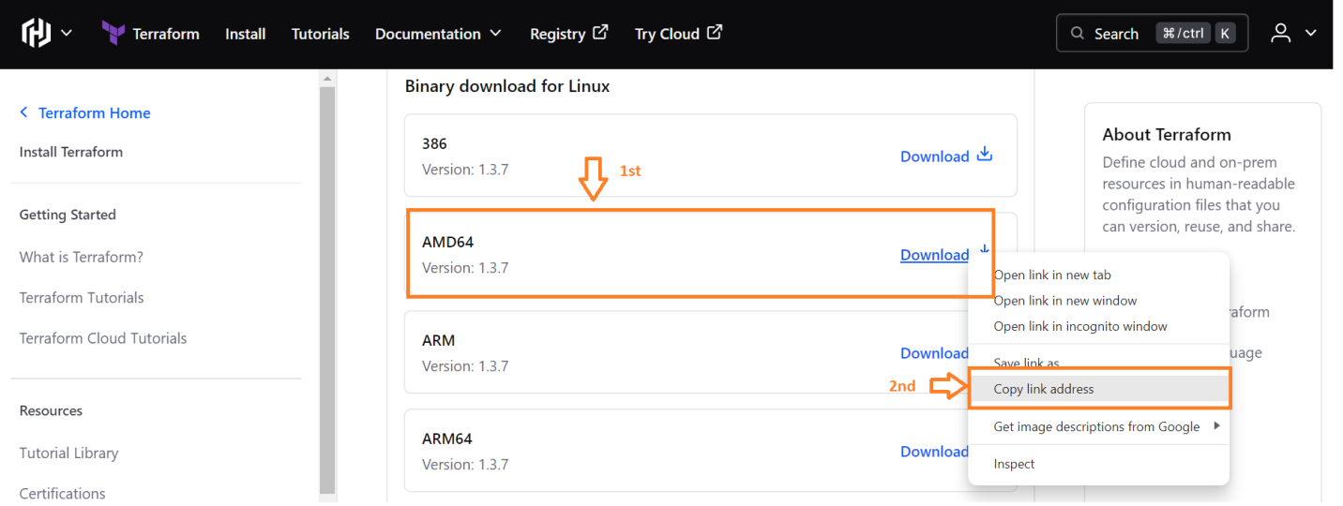

E) wget https://releases.hashicorp.com/terraform/1.3.7/terraform_1.3.7_linux_amd64.zip

F) ls

G) unzip terraform_1.3.7_linux_amd64.zip

H) ls

I) mv terraform /usr/local/bin

J) ls

K) cd /usr/local/bin

L) ls

M) terraform –v

How to create instance by using terraform?

Step1:-

Vim main.tf

terraform {

required_providers {

aws = {

source = "hashicorp/aws"

version = "5.30.0"

}

}

}

provider "aws" {

region = "us-east-1"

access_key = "access_key"

secret_key = "secret_key"

}

resource "aws_instance" "ec2" {

ami = "ami-0230bd60aa48260c6" # us-west-2

instance_type = "t2.micro"

key_name = "pritam"

tags = {

Name = "cdecb5"

}

}

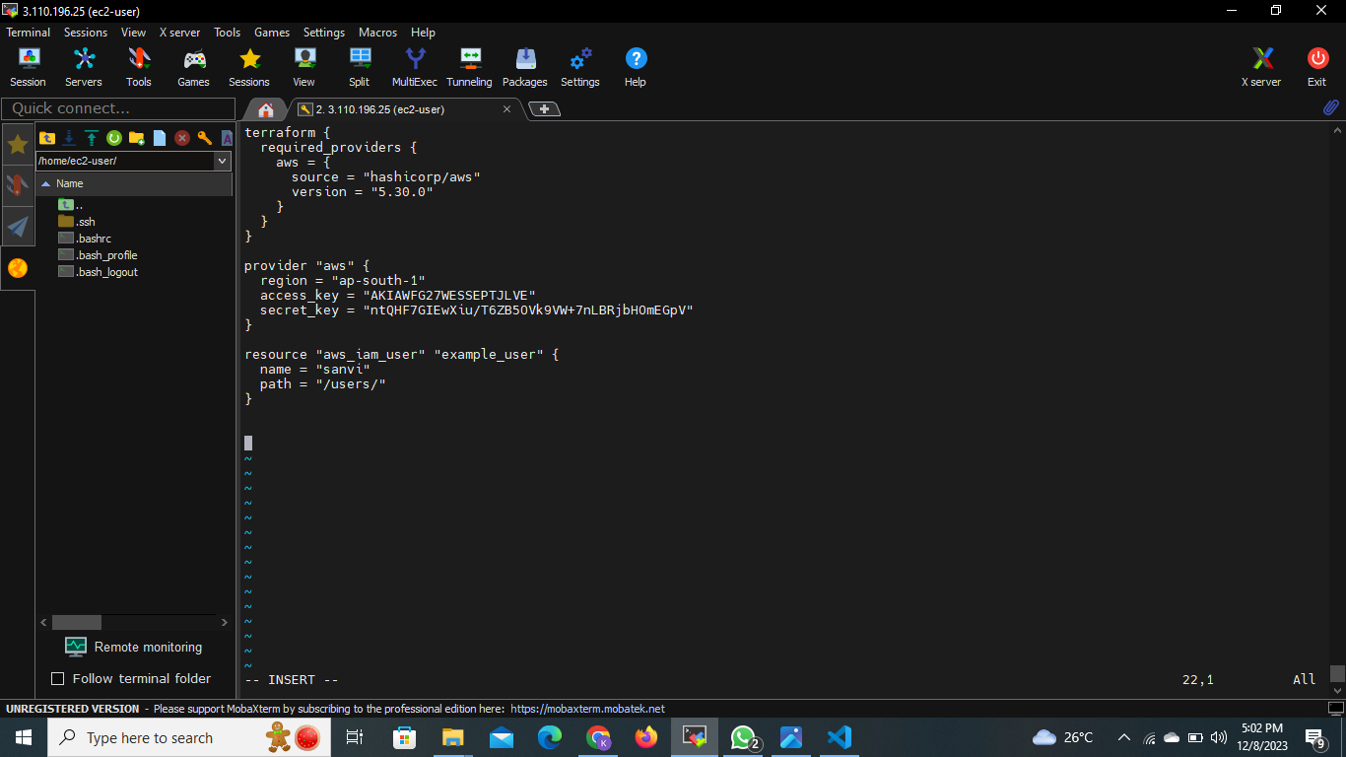

https://registry.terraform.io/providers/hashicorp/aws/latest/docs/resources/s3_bucket_object